**Unit 1 - MAGNETIC CIRCUIT**

**Marks – 10**

**CO - Use principles of magnetic circuits.**

* **Define following terms:**

1. **Magnetic circuit:** A magnetic circuit is made up of one or more closed loop paths containing a magnetic flux. The flux is usually generated by permanent magnets or electromagnets and confined to the path by magnetic cores consisting of ferromagnetic materials like iron, although there may be air gaps or other materials in the path.

Magnetic circuits are employed to efficiently channel magnetic fields in many devices such as electric motors, generators, transformers, relays, lifting electromagnets,  galvanometers, and magnetic recording heads.

1. **Magnetic Flux:** The number of magnetic lines of forces set up in a magnetic circuit is called Magnetic Flux.

These are the imaginary lines (having no physical existence) for the pictorial representation of distribution of magnetic field.

Its SI unit is Weber (Wb) and its CGS unit is Maxwell. It is denoted by φm.

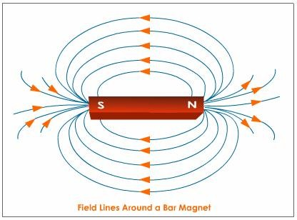

1. **Flux density:** The amount of flux passing through a unit area at right angles to the magnetic field lines is called as flux density (B).

Flux density is measured in Tesla (T) where 1 T = 1 Wbm-2.

B = Φ/A

1. **Magnetomotive force:** The magnetic pressure, which sets up the magnetic flux in a magnetic circuit is called Magnetomotive Force. The unit of MMF is Ampere-turn (AT).

F = NI

Where, N – numbers of turns of inductive coil  
 I – current

1. **Magnetic field strength:** The force experienced by a unit north pole placed at any point in a magnetic field is known as magnetic field strength at that point. It is also called field intensity or magnetizing force.

It units is newton per weber (N/Wb) or amperes per meter (A/m) .

H = B/ *µ*

1. **Permeability:** Magnetic permeability is the ability of a material to respond to how much electromagnetic flux it can support to pass through itself within an applied electromagnetic field. Permeability is denoted by µ.

permiability formula.GIF

Relative Permeability: The ratio of the permeability of a given material or medium, to the permeability of free space.

μr = μ/μ0.

1. **Reluctance:** Reluctance is the opposition to the flow of magnetic flux in a magnetic circuit.

Its unit is ampere per weber (A/Wb)

Reluctance is denoted by a ‘*S’.*

*Reluctance is directly proportional to the length of the magnetic circuit(l) and inversely proportional to the cross sectional area(a).*

S = MMF/ Φ

**Magnetic Reluctance (S) = L / a μr μ0 A/Wb**

**Where,**

L = Length of circuit in meters

a= Cross-sectional area in square meter

μr = relative Permeability

μo = Permeability of free space

1. **Permeance:**

It can be defined as the property of the magnetic circuit due to which it allows to pass the magnetic flux through it.

The permeance of magnetic circuit is the reciprocal of its reluctance.

It is similar to Conductance in an electric circuit.

Its unit is Weber per ampere.(Wb/A)

Permeance= 1/Reluctnace Wb/A

* **Compare Electric and magnetic circuits:**

|  |  |
| --- | --- |
| **Electric Circuit** | **Magnetic Circuit** |
| 1. Path traced by the current is known as electric current. | 1. Path traced by the magnetic flux is called as magnetic circuit. |
| 1. EMF is the driving force in the electric circuit. The unit is Volts. | 1. MMF is the driving force in the magnetic circuit. The unit is ampere turns. |
| 1. There is a current I in the electric circuit which is measured in amperes. | 1. There is flux φ in the magnetic circuit which is measured in the weber. |
| 1. The flow of electrons decides the current in conductor. | 1. The number of magnetic lines of force decides the flux. |
| 1. Resistance (R) oppose the flow of the current. The unit is Ohm | 1. Reluctance (S) is opposed by magnetic path to the flux. The Unit is ampere turn/weber. |
| 1. R = ρ. *l*/a. Directly proportional to *l*. Inversely proportional to a. Depends on nature of material. | 1. S = *l*/ (μ0μra). Directly proportional to *l.* Inversely proportional to μ = μ0μr. Inversely proportional to a |
| 1. The current I = EMF/ Resistance | 1. The Flux = MMF/ Reluctance |
| 1. The current density | 1. The flux density |

* **Explain Series and parallel magnetic circuits:**

1. **Series Magnetic Circuit**

The Series Magnetic Circuit is defined as the magnetic circuit having a number of parts of different dimensions and materials carrying the same magnetic field.

* Consider a circular coil or solenoid having different dimensions as shown in the figure below.
* Current I is passed through the solenoid having N number of turns wound on the one section of the circular coil. Φ is the flux, sets up in the core of the coil.
* a1, a2, a3 are the cross-sectional area and *l1, l2, l3 are* the length of the three different coils having different dimension joined together in series.
* µr1, µr2, µr3are the relative permeability of the material of the circular coil.

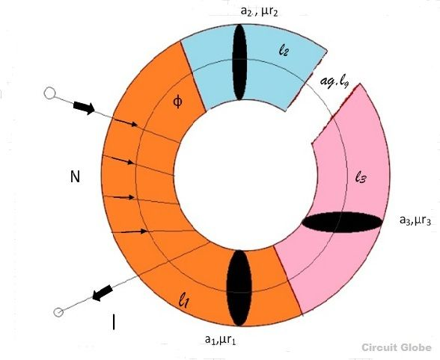

* The total reluctance (S) of the magnetic circuit is

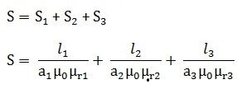

* Total MMF = φ x S ……..…. (1)
* Putting the value of S in equation (1) we get

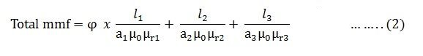

* (As B = φ/a) putting the valve of B in the equation (2) we obtain the following equation for the total MMF

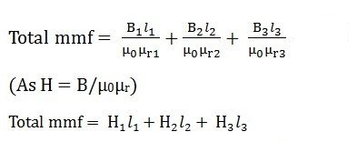

* Total MMF = H1*l*1 + H2*l*2 + H3*l3*+ ……….. + Hn*ln*

1. **Parallel Magnetic Circuit:**

A magnetic circuit having two or more than two paths for the magnetic flux is called a parallel magnetic circuit.

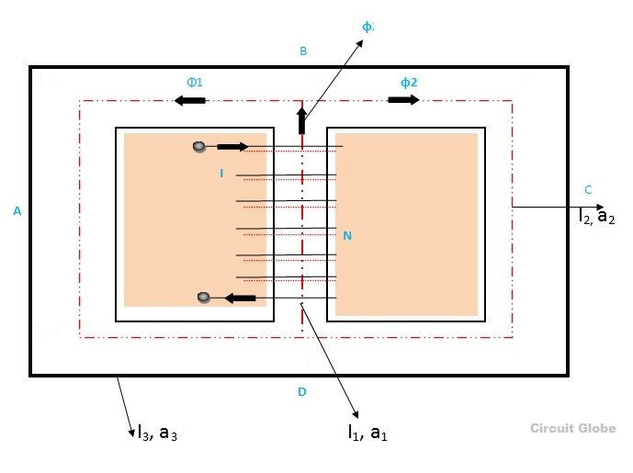

* The parallel magnetic circuit contains different dimensional areas and materials having various numbers of paths.
* In such a circuit, each path requires the same MMF and the total flux divides between the paths in inverse proportion to their reluctances.
* For such circuit,

Total flux φ = φ1 + φ2 + φ3 + ……. + φn …..(1)

Where φ1 , φ2 , φ3 are the fluxes in the individual paths.

* If S1, S2, S3 etc, are the reluctances of various parallel paths of the magnetic circuit, then similar to electric circuits, the equivalent reluctance S for parallel combination is given by the relationship,

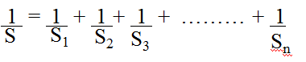

**Important Formulae:**

* Flux density B = φ/A
* Magnetomotive force MMF = NI
* Magnetic field strength H = B/ μ = NI / *l*
* Permeability μ = B/H
* Relative permeability μr = μ/μ0.
* Reluctance s = MMF/ φ = *l* / (μ0μra).
* **State Faraday’s laws of Electromagnetic induction:**
* **Faraday’s First Law:**

This law states that whenever the number of lines of force linking with a circuit changes, an emf is always induced in it; or whenever a conductor cuts or is cut by the magnetic flux, an emf is always generated in it.

* **Faraday’s Second Law:**

It states that the magnitude of the induced emf in any circuit is proportional to the rate of change of its flux linkages (flux x turns); or the magnitude of the generated emf in any conductor is proportional to the rate at which it cuts or is cut by the magnetic flux.

* **Magnitude of induced emf:**
* If the flux linking with a particular coil having N turns changes from φ1 to φ2 Webers in small time of ‘t’ seconds, then
* Rate of change of flux linkages = (Final flux linkage) – (Initial flux linkage)

Time

= Nφ2 – Nφ1

t

* According to Faraday’s law of electromagnetic induction, the induced emf (e) is given by

e ∝ Rate of change of flux linkages

∝ = Nφ2 – Nφ1

t

e = KN (φ2 – φ1) Volts

t

where K is the constant of proportionality.

* Expressing the above equation in differential form, we get

e = KN dφ

dt

* Direction of Induced EMF:
* Whenever, a current carrying conductor comes under a magnetic field, there will be a force acting on the conductor and on the other hand, if a conductor is forcefully brought under a magnetic field, there will be an induced current or EMF in that conductor.
* In both of the phenomenons, there is a relation between magnetic field, current and force.
* This relation is directionally determined by Fleming's Left Hand rule and Fleming's Right Hand rule respectively.
* Fleming's Left Hand rule is mainly applicable for electric motor and Fleming's Right Hand rule is mainly applicable for electric generator.
* **Fleming Right Hand Rule:**

If a conductor is forcefully brought under a magnetic field, there will be an induced current or EMF in that conductor. then direction of the induced current or EMF is given by Fleming’s Right Hand Rule.

Statement:

Hold out the right hand with the first finger, second finger and thumb at right angle to each other. If fore finger represents the direction of the line of force, the thumb points in the direction of motion or applied force, then second finger points in the direction of the induced current.

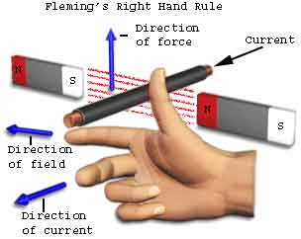

* **State Lenz’s law.**
* Lenz's law obeys Newton's third law of motion (i.e to every action there is always an equal and opposite reaction).
* Lenz's law states that when an emf is generated by a change in magnetic flux according to Faraday's Law, the polarity of the induced emf is such, that it produces an current that's magnetic field opposes the change which produces it.
* **Types of induced EMF:**

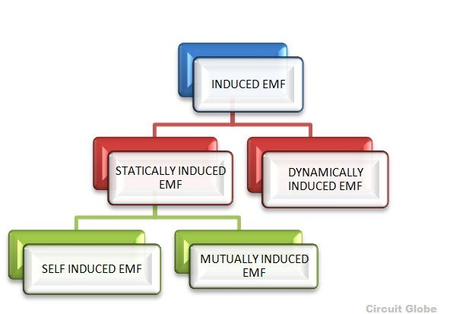

1. **Dynamically Induced Emf:**

In dynamically induced emf the magnetic field system is kept stationary, and the conductor is moving, or the magnetic field system is moving, and the conductor is stationary thus by following either of the two process the conductor cuts across the magnetic field and the emf is induced in the coil.

* **Magnitude of Dynamically Induced EMF:**

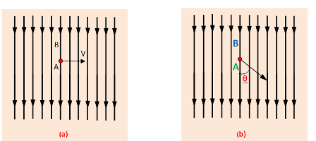

* Consider conductor A with length *l* lied in magnetic field with flux density B Wb/m2.

1. **Linear motion:**

If conductor moves linearly distance dx in time dt as shown in fig (a), then magnitude of induced emf will be

mag of d emf.png

1. **Angular Motion:**

If conductor moves at an angle θ with the direction of flux which is shown in (b), then magnitude of induced emf will be

mag of d emf 1.png

1. **Statically Induced Emf:**

This type of EMF is generated by keeping the coil and the magnetic field system, both of them stationary at the same time; that means the change in flux linking with the coil takes place without either moving the conductor (coil) or the field system. This change of flux produced by the field system linking with the coil is obtained by changing the electric current in the field system.

* Types of statically induced emf:

1. **Self-induced emf:**

Self-induced e.m.f is the e.m.f which is produced in the coil due to the change of its own flux linked with it. If the current of the coil is changed, then the flux linked with its own turns will also change which will produce an e.m.f that is called self-induced e.m.f.

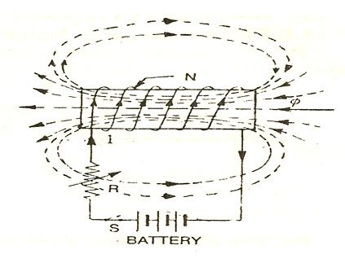

* Consider a coil having N number of turns as shown in the above figure. When the switch S is closed and current I flows through the coil, it produces flux (φ) linking with its own turns. If the current flowing through the coil is changed by changing the value of variable resistance (R), the flux linking with it, changes and hence emf is induced in the coil. This induced emf is called Self Induced emf.
* **Magnitude of Self Induced EMF:**
* According to Faraday's law of magnetism induction, self-induced e.m.f. is expressed as

                            e = -N (dΦ/dt)

* The flux is expressed as

 Φ = (Flux / Ampere) x Ampere = (Φ/I) x I

* Now for a circuit, as long as permeability ‘µ' is constant, magnitude relation of flux to current (i.e. Φ/I) remains constant.
* Rate of change of flux = (Φ/I) x rate of change of current.
* Substituting this in expression for the induced emf, we get

e = -N(Φ/I)x Rate of change of I

= -(NΦ/I)x Rate of change of I

* The constant (NΦ/I) is called the co-efficient of self induction or co-efficient of self inductance and denoted by L the unit of inductance is henry.

1. **Mutually induced emf:**

The emf induced in a coil due to the change of flux produced by another neighbouring coil linking to it, is called Mutually Induced emf.

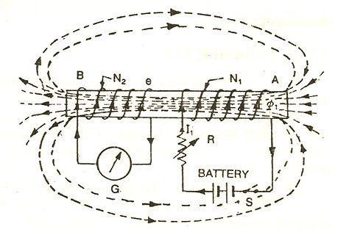

* Consider a coil AB. Coil B is having N2 number of turns and is placed near another coil A having N1 number of turns as shown in the figure below.
* When the switch (S) is closed in the circuit shown above current I1 flows through the coil A, and it produces the fluxφ1. Most of the flux says φ2 links with the other coil B.
* If the current flowing through the coil A is changed by changing the value of variable resistor R, it changes flux linking with the other coil B and hence emf is induced in the coil. This induced emf is called Mutually Induced emf.
* **Magnitude of mutually Induced EMF:**
* Let, N1= Number of turns of coil A

N2 = Number of turns of coil B

I1 = Current flowing through coil A

Φ1 = Flux producing due to current I1 in webers.

Φ2 = Flux linking with coil B

* According to Faraday’s law, the induced e.m.f in coil B is,

                E2 = -N2  (dΦ2/dt)

* Negative sign indicates that this e.m.f. will set up a current which will oppose the change of flux likning with it.

                      Now Φ2 = Φ2/I1 x I1

* If permeability of the surrounds is assumed constant then Φ2 ∝ I1 and hence Φ2/I1 is constant.

∴ Rate of change of Φ2 = (Φ2/I1) x Rate of change of current I1

                     ∴  dΦ2/dt = (Φ2/I1)  x (dI1/dt)

                                    E2 = -N2 x ( Φ2/I1)  x (dI1/dt)

                                    E2 = - (N2 Φ2/I1) (dI1/dt)

* Here (N2 Φ2/I1) is called coefficient of mutual inductance denoted by M.

                                     E2 = -M(dI1/dt) Volts

* **Magnetic Hysteresis:**
* The phenomenon of flux density B lagging behind the magnetizing force H in a magnetic material is known as **Magnetic Hysteresis.**
* If the field intensity H is gradually increased, then the flux density also increases till it reaches the saturation point ‘a’ and the curve obtained is ‘oa’.
* If the magnetizing force is gradually reduced to zero, but the value of flux density will not be zero as it still has the value ob when H=0, so the curve obtained is ab as shown in the figure below. This value ob of flux density is because of the residual magnetism.
* Due to magnetization process and H is increased agin in the positive direction tracing the path as ‘efa’, and finally the hysteresis loop is complete.
* In the curve again of is the magnetizing force, also known as the Coercive force required to remove the residual magnetism ‘oe’.
* From the above discussion, it is clear that the flux density B always lags behind the magnetizing force H. Hence the loop **‘abcdefa’** is called the**Magnetic Hysteresis loop** or **Hysteresis Curve**

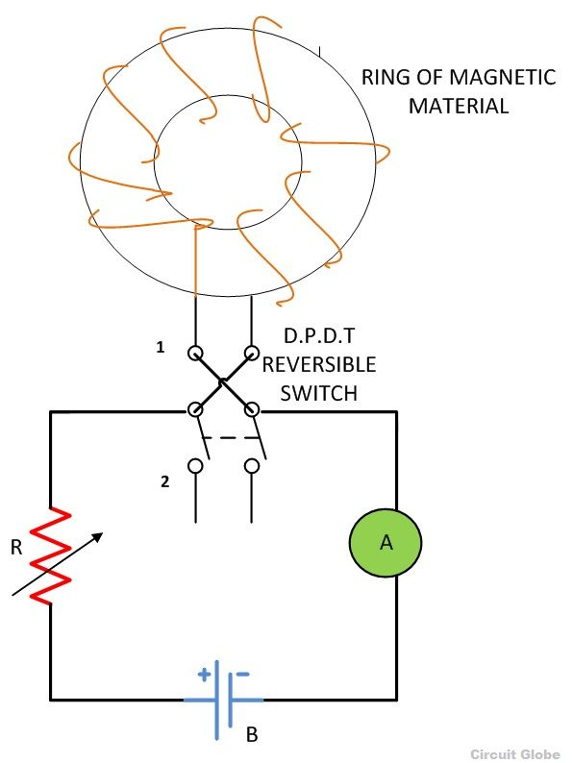 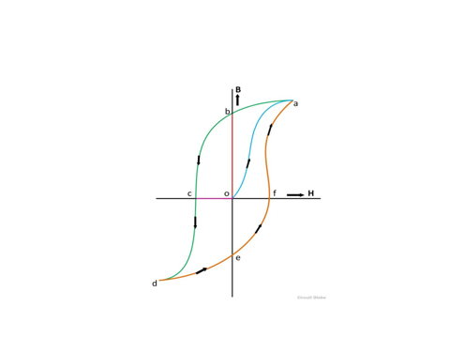

* **Summary of magnetic hysteresis:**

|  |  |  |  |  |  |
| --- | --- | --- | --- | --- | --- |
| Switch position | R resistance | I current | H magnetizing force | B flux density | Curve |
| 1 | Decreases | Increases | Increases | Increases till saturation point a | oa |
|  | Saturation point: when on increasing the current the dipole moment or the molecules of the magnet material align itself in one direction. | | | | |
|  | Increases | Decreases gradually & I=0 | Gradually reduced to 0 i.e. H=0 | Decreases but B ≠ 0  B= ob (residual magnetism) | ab |
| 2 | Decreases | Increases in reverse direction | Increases in reverse direction | Decreases and B=0 | bc |
|  | Decreases | Increases in reverse direction | Increases in reverse direction | Decreases & reaches saturation point d | Cd |
|  | Increases | Decreases gradually & I=0 | Gradually reduced to 0 i.e. H=0 | Increases but B ≠ 0  B= oe (residual magnetism) | De |
| 1 | Decreases | Increases | Increases in positive direction | Increases | efa |

* **Residual Magnetism:**

The value of flux density when exciting current and therefore magnetic field strength is reduced to zero is called remanent or residual flux density.

* **Coercive Force:**

The value of the magnetizing force oc required to wipe out the residual magnetism ob is called Coercive force.

**Explain various losses in magnetic circuit.**

**Hysteresis Loss:**

The work was done by the magnetising force against the internal friction of the molecules of the magnet, produces heat. This energy which is wasted in the form of heat due to hysteresis is called Hysteresis Loss.



where Kh = A characteristic constant called steinmetz hysteresis co-efficient for the material

Bm = Maximum flux density, in teslas

f = Frequency

v = Volume of the magnetic material, in cubic meters.

**Eddy Current Loss:**

* When magnetic core which itself is composed of conducting material like iron is subjected to such a varying or an alternating magnetic flux, the emfs are induced in it in accordance with Faraday’s law of electromagnetic induction.
* These emfs give rise to circulating currents in the core which are called eddy currents.
* The power (or I2R) loss due to the eddy currents in the resistance of the core is known as the eddy current loss.

**Core Loss or Iron Loss:**

* The total power loss in the core on account of hysteresis and eddy currents taken together is known core loss or iron loss.

**Unit 2 - AC FUNDAMENTALS**

**Marks – 10**

**CO: Use single phase AC supply for electrical and electronics equipment.**

* **AC and DC Quantity:**
* **Alternating current (AC):**

An AC is one which periodically passes through a definite cycle of changes in respect of magnitude as well as direction.

* **Direct current (DC):**

The DC is that current which flows continuously in one direction and has constant magnitude with respect to time.

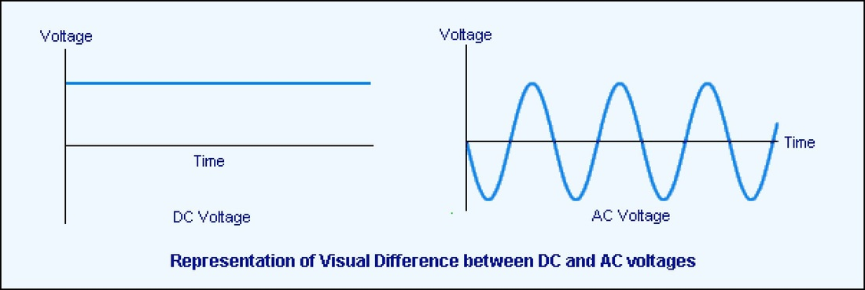

* **Advantages of A.C. over D.C.:**

1. Since it is possible to build up high-voltage, high speed ac generators with very large capacities, their construction and operating costs per kilowatt are low. This is not possible in the case of dc generator.
2. The ac voltage can be raised and lowered very easily with the help of transformer. Raising and lowering of dc voltage is not so easy and economical.
3. Due to adoption of high voltages, ac transmission is always efficient and economical. This because, higher the voltage, lesser is the current flowing through the transmission line conductors for the given power. Consequently, the weight of conductor material and power loss in the line itself are reduced.
4. AC motors are simple in construction, cheaper and more efficient than DC motors and required less maintenance.
5. AC can be easily converted to DC for the applications like telephone and telegraph system, charging storage batteries etc. due to small requirement, the generation of dc power for above applications at ordinarily used voltages would be very uneconomical.

* **Single phase AC Waveforms:**

1. **Waveform:**

A waveform is a graph of magnitude of a quantity with respect to time. The quantity plotted on the X-axis is time and the quantity plotted on the Y-axis will be voltage, current, power etc.

* **Mathematical representation:**

The voltage wave form is mathematically represented as,

v(t) = Vm sin(2πf0t) ……(1)

Where v(t) = Instantaneous voltage,

Vm = Peak value (or maximum value)

f0 = Frequency in Hz. (f0 = 1/T0)

and “sin” represents the shape of the waveform.

Similarly the current waveform is mathematically represented as,

i(t) = Im sin(2πf0t)

Where i(t) = Instantaneous current,

Im = Peak value (or maximum value)

f0 = Frequency in Hz.

1. **Instantaneous value:**

The instantaneous value of an ac quantity is defined as the value of that quantity at particular instant of time.

1. **Cycle:**

In an ac waveform, a particular portion consisting of one positive and negative part repeats many times. Each repetition consisting of one positive & one identical negative part is called as one cycle of the waveform.

1. **Time Period or Periodic Time (T):**

Time period (T) is defined as the time taken in seconds by the waveform of an ac quantity to complete one cycle. After every T seconds, the cycle repeats itself as shown in fig.(b).

1. **Frequency:**

Frequency is defined as the number of cycles completed by an alternating quantity in one second. It is denoted by “f” and its units are cycles/second or Hertz (Hz).

Frequency is defined as the number of cycles completed by an alternating quantity in one second. It is denoted by “f” and its units are cycles/second or Hertz (Hz).

1. **Amplitude**:

The maximum value attained by an alternating quantity during its positive or negative half cycle is called its amplitude or peak value.

1. **Angular Velocity (ω):**

The angular velocity (ω) is the rate of change of angle ωt with respect to time.

∴ ω = dθ/ dt ……(1)

∴ dθ = 2π

∴ ω = 2π/T …..(2)

But 1/T = f

∴ ω = 2πf

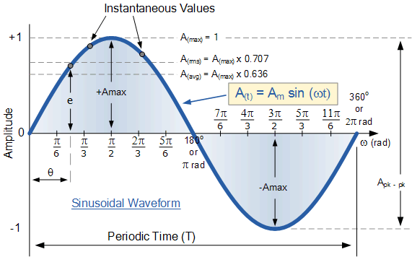

1. **Effective or R.M.S. Value:**

The effective or RMS value of an ac current is equal to the steady state or DC current that is required to produce the same amount of heat as produced by the ac current provided that the resistance and time for which these currents flow are identical.

RMS value of a sinusoidal waveform is equal to 0.707 times its peak value.

1. **Average Value:**

The average value of an alternating quantity is equal to the average of all, the instantaneous values over a period of half cycle.

The average value of a sinusoidal waveform is 0.637 times its peak value.

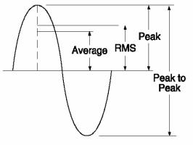

1. **Form Factor:**

The form factor of an alternating quantity is defined as the ratio of its RMS value to its average value.

∴ Form factor Kf = RMS value / Average value

1. **Crest Factor or Peak Factor (Kp):**

The crest factor is defined as the ratio of the crest/ peak value to the rms value of the quantity.

∴ Kp = Peak value / RMS value

* **Phasor Representation of an AC Quantity:**
* A phasor is a straight line with an arrow marked on one side.
* The length of this straight line represents the magnitude of the sinusoidal quantity being represented and the arrow represents its direction.

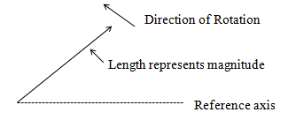

* **Phase angle:**

The equation of the induced emf in the conductor is

v = Vm sin ωt = Vm sinθ …… (1)

In equation (1), θ is the angle made by the conductor with the reference axis & it is called as the Phase Angle.

* **Phase Difference:**

If two waveforms do not have the same zero crossover point so, we say that there is a phase difference between them.

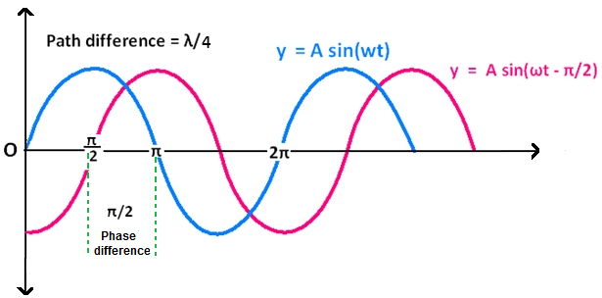

* Both VA and VB have the same frequency & same peak voltage.
* We can represent two voltages mathematically as follows:

VA = A sin ωt

VB = A sin (ωt – π/2 )

VB = A sin (ωt – ø ) (ø = π/2 ) ……..(2)

* The angle π/2 is known as the phase difference between VA and VB.
* **Leading phase difference:**

If the phase angle ø in equation (2) is positive then the phase difference ø is said to be a leading phase difference. In other words, we say that voltage VB leads the voltage VA.

* **Lagging phase difference:**

If the phase angle ø in equation (2) is negative, then the phase difference is said to be a lagging phase difference. That means VB lags behind VA by ø.

* **Representation of AC Quantity in Rectangular & Polar Form:**
* A phasor can be presented in two different ways:

1. Rectangular form

2. Polar form.

* The instantaneous voltage

v(t) = Vm sin (ωt + ø) ……(1)

is represented using a phasor as shown in fig.1

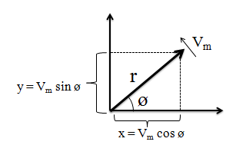

1. **Polar Representation:**

* The equation (1) can be represented in the polar form as follows:

v(t) = r ∠ ø ……..(2)

where r = Vm.

* That means length of phasor (r) represents the peak value of the ac quantity.
* The polar form is suitable for multiplication and addition of phasors.

1. **Rectangular Representation:**

* The equation (1) can be represented in the rectangular form as follows:

v(t) = x + jy ……(3)

where x = x component of the phasor = Vm cos ø

y = y component of the phasor = Vm sin ø

* Substituting the values of x and y components into equation (3), we get,

v(t) = Vm cos ø + j Vm sin ø …..(4)

* Rectangular form is suitable for addition & subtraction of phasors.
* **Single Phase AC Circuits:**
* The three basic elements of any ac circuit are Resistance (R), Inductance (L), and capacitance (C).
* The three basic circuits are:

1. Purely resistive AC circuit.
2. Purely inductive AC circuit.
3. Purely capacitive AC circuit.

* **Reactance**:

Reactance can be of two types:

1. **Inductive reactance XL:**

XL = ωL = 2πfL and the unit is ohm (Ω ).

Inductive reactance is the opposition to the flow of an alternating current, offered by an inductance.

1. **Capacitive reactance XC:**



The unit of capacitive reactance is ohm (Ω).

capacitive reactance XC is defined as the opposition offered by a pure capacitor to the flow of alternating current.

* **Impedance:**
* If circuit contains combination of R, L and C, then equivalent resistance of this circuit is called Impedance, denoted by ‘Z’ and unit is ohm.
* **In polar form:**

Z = |Z| ∠ ø

where |Z| = magnitude of Z,

ø = phase angle

* **Rectangular form:**

Z = R + jX

where |Z| = √(R2 + X2) and ø = tan-1[X/R]

* **Purely Resistive AC Circuit:**
* It consists of an ac voltage source v = Vm sin ωt, and a resistor R connected across it.

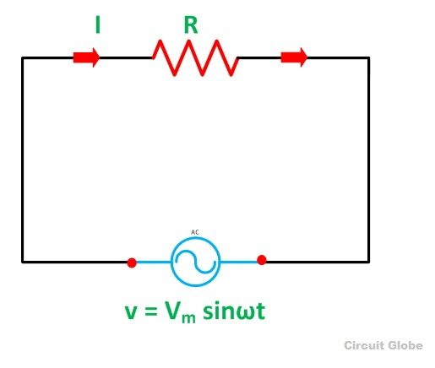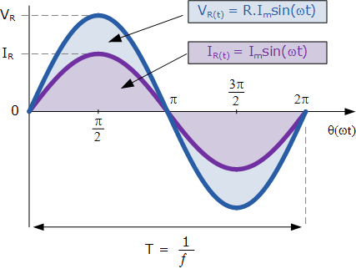

* + Instantaneous Voltage across resistor vR = v = Vm sin ωt
  + Instantaneous current flowing through the resistor is given by,

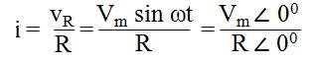



* **Phasor Diagram:**

The current through the resistive circuit and the applied voltage are in phase with each other.

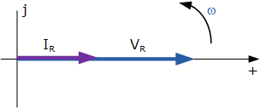

* **Impedance of the purely resistive circuit:**

When the load is purely resistive, the reactive part is zero.

∴ Z = R Ω

In the polar form it is given by,

Z = R ∠ 00 Ω

* **Average Power (Pav):**

The average power supplied by the source and consumed by the pure resistor R connected in an AC circuit is given by,

Pav = VRMS IRMS

* **Purely Inductive AC Circuit:**

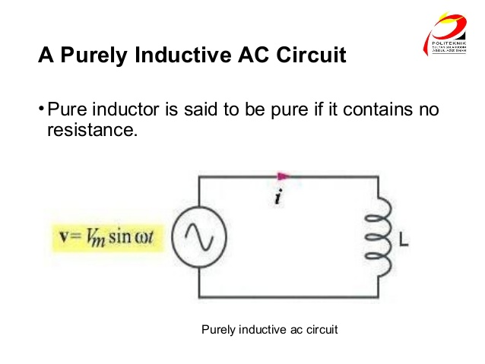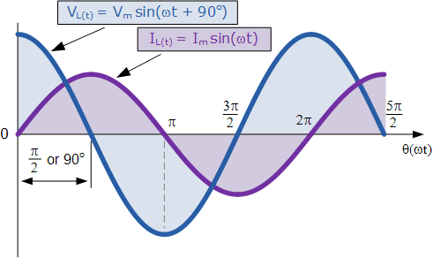

* Instantaneous voltage across inductor is v = Vm sin (2πft)
* Instantaneous current i = Im sin (2πft – π/2)

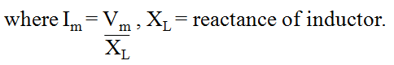

* **Phasor Diagram:**

Current lags behind the applied voltage by 900 or π/2.

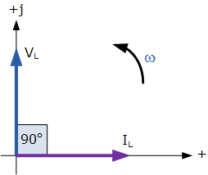

* **Instantaneous power (P):**

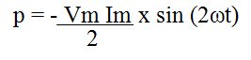

* **Average power:**

Pav = 0

* **Impedance of a purely inductive circuit:**

When circuit is purely inductive, the resistive part is zero i.e. R = 0.

∴ Z = j XL Ω

In polar form, it is given by,

Z = XL ∠ 900 Ω

* **Purely Capacitive AC Circuit:**

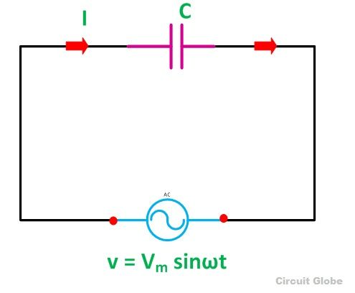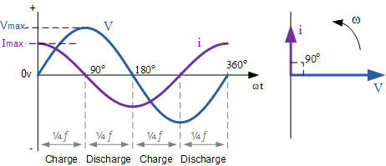

* Instantaneous voltage is v = Vm sin (2πft)
* Instantaneous current is i = Im sin (2πft + π/2)

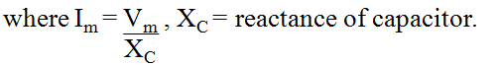

* **Phasor Diagram:**

Current leads the applied voltage by 900 or π/2.



* **Instantaneous power (P):**



* **Average power:**

Pav = 0

* **Impedance of a purely capacitive circuit:**

When circuit is purely capacitive, the resistive part is zero i.e. R = 0.

∴ Z = - j XC Ω

In polar form, it is given by,

Z = XC ∠ -900 Ω

* **The Series R-L Circuit:**
* In the series R-L circuit. AC voltage source of instantaneous voltage v = Vm sin(ωt) is connected across the series combination of L and R.
* Assume that the current flowing through L and R is I amperes, where I is the rms value of the instantaneous current i.
* Due to this current, the voltage drop across L and R are given by:

voltage drop across R, VR = I. R (VR is in phase with I)

voltage drop across L, VL = I. XL (VL leads I by 900)

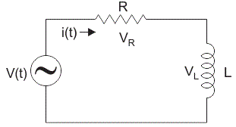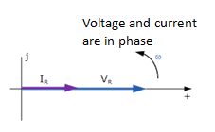

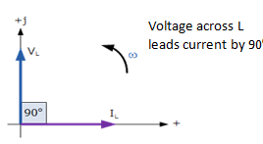

* **Phasor Diagram:**

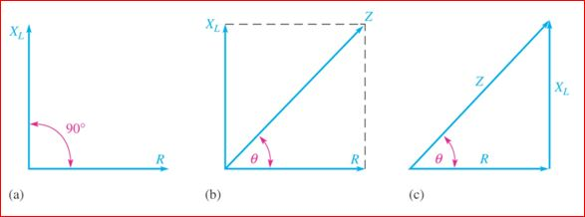

* **Impedance triangle:**

As shown in fig. (c), sides of this triangle represents the resistance, reactance and impedance of the circuit, it is known as impedance triangle.

* **Impedance of R-L series circuit:**

In rectangular form:

Z = R + jXL

In polar form:

Z = |Z| ∠ ø

where |Z| = √(R2 + XL2) and ø = tan-1[XL/R]

* **Voltage and current waveform:**



In RL series circuit supply voltage v leads current i by a phase angle ø or current lags behind voltage by ø.

Hence v = Vm sin (ωt) & i = Im sin (ωt- ø)

* **Average Power in Series L-R Circuit:**
* The average power supplied to the R-L circuit is,

Pav = (Average power consumed by R) + (Average power consumed by L)

But the average power consumed by pure inductance is zero.

∴ Pav = Average power consumed by R

* **The Series R-C Circuit:**
* In the series R-C circuit. AC voltage source of instantaneous voltage v = Vm sin(ωt) is connected across the series combination of C and R.
* Assume that the rms value of current flowing through C and R be equal to I amperes, the voltage drop across C and R are given by:

voltage drop across R, VR = I. R (VR is in phase with I)

voltage drop across C, VC = I. XC (VC lags I by 900)

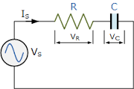 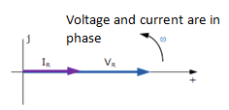

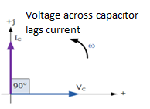

* **Phasor Diagram:**

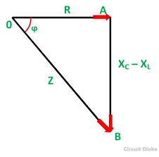

* **Impedance of R-C series circuit:**

In the rectangular form:

Z = R - jXC

In polar form:

Z = |Z| ∠ -ø

where |Z| = √(R2 + XC2) and ø = tan-1[-XC/R]

The phase angle is negative for capacitive load.

* **Voltage and current waveform:**

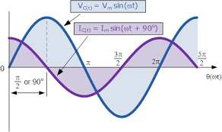

In RC series circuit supply voltage v lags behind current i by a phase angle ø or current leads voltage by ø.

Hence v = Vm sin (ωt) & i = Im sin (ωt + ø)

* **Average Power in Series L-C Circuit:**

The average power supplied to the R-L circuit is,

Pav = (Average power consumed by R) + (Average power consumed by C)

But the average power consumed by pure capacitance is zero.

∴ Pav = Average power consumed by R

* **Power Triangle:**
* Different types of powers are-

1. Apparent power S (volt ampere VA)
2. Active power P (watts)
3. Reactive power Q (volt ampere VAR)
4. **Active power:**

The true or real power in the a.c. circuit which is given by the product of the applied voltage and the active component of the current (i.e. P = V I cos Ø) is called active power.

1. **Reactive power:**

The quantity VI sin Ø which is product of the applied voltage and reactive component of the current is called reactive power.

1. **Apparent power :**

The product of RMS value of voltage  and current is known as  Apparent power .

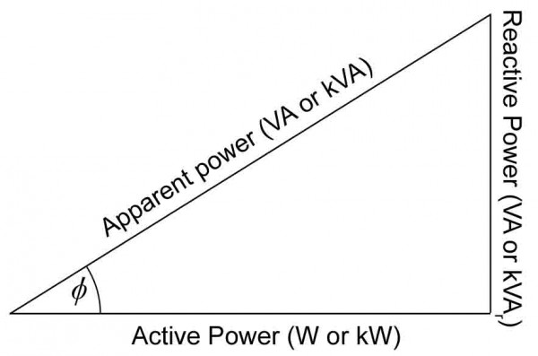

Power triangle is right angle triangle in which adjusant side of phase angle represent active power, opposite side represent reactive power and hypotenuse represent apparent power.

* **Power factor and its significance:**

In an a.c. circuit

P = V I cos Ø

where cos Ø is the power factor of the circuit.

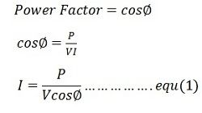

* An increase in the system current caused by low power factor leads to the following disadvantages:

1. Larger alternators, transformers and transmission line conductors are required. This increases the cost of these equipments.
2. Increased power losses reduce the efficiency of the supply system as a whole.
3. A large voltage drop in the transmission line necessitates the installation of expensive equipments in order to keep up the voltage at the far end.

* In general, it can be concluded that for a given power, the lower the power factor, the greater is the cost of generation and transmission.
* The supply undertakings, therefore, always encourage the consumers to increase their power factor by way of charging less for their consumption of electricity. It is always advantageous for both, the consumers as well as suppliers to work at a higher improved power factor.

**Unit 3 - POLYPHASE AC CIRCUITS**

**Marks – 10**

**CO: Use three phase AC supply for industrial equipment and machines.**

**Introduction to Polyphase AC Circuits**

* The domestic ac supply is single phase ac supply with 230V/50Hz.
* But this ac supply is not suitable for certain applications. Some need a polyphase ac supply.
* Polyphase ac supply is the one which produces many phases simultaneously.
* **How to generate a polyphase ac supply?**
* The single phase ac voltage is generated by using a single phase alternator. Single phase alternator consists of only one armature winding.
* But in order to generate a polyphase voltage, we have to use many armature winding. The number of windings is equal to the number of phases.
* **Three Phase Supply waveforms:**

**Draw the waveform representation of three phase supply with neat labels.**

* A three phase system has proved to be the most economical as compared to the other systems. Hence in practice the three phase systems is most preferred.
* The three armature windings used for generation of a three phase supply are located at 1200 away from each other.
* The voltages induced in these windings are of same amplitude and frequency, but they are displaced by 1200 with respect to each other as shown in fig.(1).

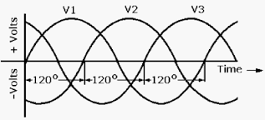

* **Advantages of Three Phase Systems over Single Phase System:**

1. **More output:** The output of a three phase machine is more than that of single phase machine of the same size.
2. **Smaller size:** Three phase machine is always smaller, lighter and therefore cheaper than single phase machine of the same rating.
3. **Three phase motors are self starting:** Most of the single phase motors are not self starting. Three phase motors are self starting.
4. **More power is transmitted:** In the transmission system, it is possible to transmit more power using three phase system than single phase system using the conductors of same cross sectional area.
5. **Smaller cross-sectional area of conductor:** If same amount of power is to be transmitted, then the cross sectional area of the conductors used for the three phase system is small as compared to that for the single phase system.
6. **Better power factor:** The power factor of three phase machine is better than that of the single phase machine.

**Comparison of Single Phase & Three Phase Systems**

|  |  |  |  |
| --- | --- | --- | --- |
| **Sr. No.** | **Parameter** | **Single phase system** | **Three phase system** |
| 1. | Voltage | Low(230 V) | High (415V) |
| 2. | Transmission efficiency | Low | High |
| 3. | Size of machines to produce same output | Larger | Smaller |
| 4. | Cross sectional area of conductors | Large | Small |
| 5. | Usage | Domestic, small power applications | Industrial, large power applications |

* **Three Phase Emf Generation & its Waveform:**
* **Principle:**
* The single phase supply is generated using a single turn alternator.
* Thus if armature consists of only one winding, then only one alternating voltage is produced.
* But if the armature winding is divided into three groups which are displaced by 1200 from each other, then it is possible to generate three alternating voltages.
* As shown in fig. the armature winding is divided into three groups. The three coils are R-R’, Y-Y’ and B-B’.
* All these coils are mounted on the same shaft and are physically placed at 1200 from each other.
* When these coils rotate in the flux produced by the permanent magnet, emf in induced into these coils. As shown in fig.(2), these emf are sinusoidal, of equal amplitudes and equal frequency but they are displaced from each other by 1200.
* VR, VY and VB are three phase voltages.

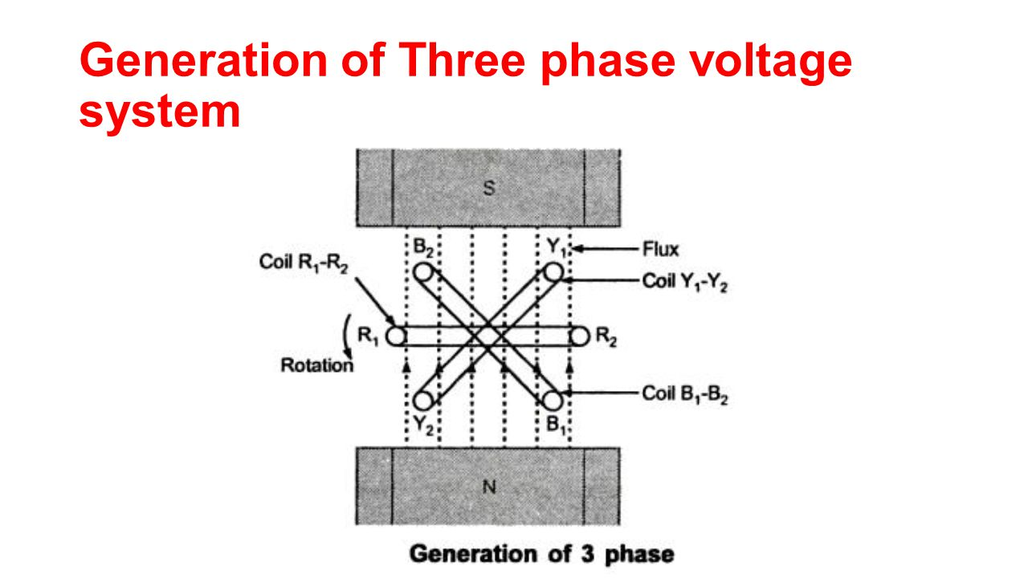

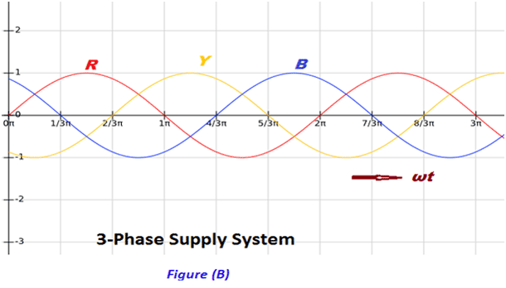

* If VR is considered as the reference, then we conclude that,

VY lags VR by 1200.

VB lags VY by 1200.

In other words, VB lags VR by 2400.

* **Phasor Diagram:**

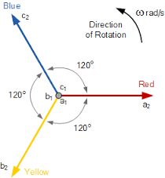

* **Mathematical representation:**

VR = Vm sin ωt

VY = Vm sin (ωt-1200)

VB = Vm sin (ωt-2400) = Vm sin (ωt+1200)

**Define Phase sequence:**

The phase sequence is defined as the sequence in which the three phases reach their maximum values. Normally the phase sequence is R-Y-B.

**Importance of phase sequence:**

* The direction of rotation of three phase machines depends on the phase sequence.
* If the phase sequence is changed e.g. R-B-Y then the direction of rotation will be reversed.
* In order to avoid such things, the phase sequence of R-Y-B is always maintained.
* **Three Phase supply Connection**

|  |  |  |
| --- | --- | --- |
| 3wire star.png | 4 wire star.png | del conn.jpg |

* **Star Connection(wye connection):**
* This configuration is obtained by connecting one end of the three phase winding together.
* We can connect either R Y B or R’ Y’ B’ together. This common point is called as the Neutral Point.

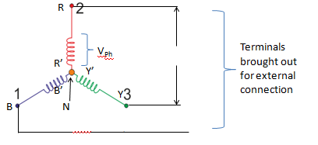

* **Delta Connection:**
* Delta or mesh configuration is obtained by connecting one end of winding to the starting end of the other winding such that it produces a closed loop.

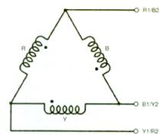

* **Types of Loads:**
* **Balanced load:**

A balanced load is that in which magnitudes of all impedances connected in the load are equal and the phase angles of them also are equal and of same type (inductive, resistive or capacitive).

* **Unbalanced load:**

If load doesn’t satisfy the condition of balanced, then it is called as the unbalanced load.

The magnitudes and phase angles of the unbalanced loads are differ from each other.

* **Line voltages & Phase voltages:**
* **Line voltage:**

If R, Y and B are called as the supply lines, then the potential difference between any two lines is known as the line voltage.

VRY, VRB, VYB, VYR, VBR and VBY are six possible line voltages.

All the line voltages are sinewaves of 50 Hz frequency and the phase shift between the adjacent line voltage is 600.

* **Phase voltages:**

The voltage measured across a single winding or phase is called as phase voltage.

All the phase voltages are sinewaves and the phase difference between the adjacent phase voltages is 1200.

* **Line current & Phase current:**
* **Line current:**

The current passing through any line R, Y, B is called as the line current. It is denoted by IL.

* **Phase current:**

The current passing through any branch of the star connected load is called as the phase current. It is denoted by Iph.

* **Balanced Star Load:**

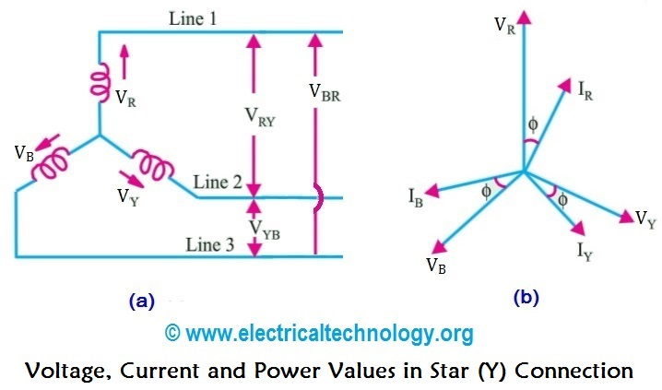

* **Relation between line and phase voltages:**

In the star connected system, the line voltage is higher than the phase voltage by factor √3.

∴ line voltage = √3 phase voltage.

* **Relation between line and phase current:**

For star connected load IL =Iph.

* **Equations for three phase power:**
* In single phase ac circuit, the power consumed in each phase is given by,

Pph = Vph Iph cos ø ….(1)

where ø = angle between Vph and Iph

* For balanced three phase system, the total power consumed will be given by,

PT = 3 Pph = 3 Vph Iph cos ø …..(2)

* substituting Vph = VL/√3 and Iph = IL, we get,

Total power PT = 3 x VL/√3 x IL cos ø

∴ PT = √3 VL IL cos ø

* **Power factor:**

The load power factor for a 3 phase balanced star load is equal to the power factor of each phase in the load.

∴ overall P.F. = cos ø

where ø = angle between the phase voltage and phase current

* **The complete phasor diagram:**

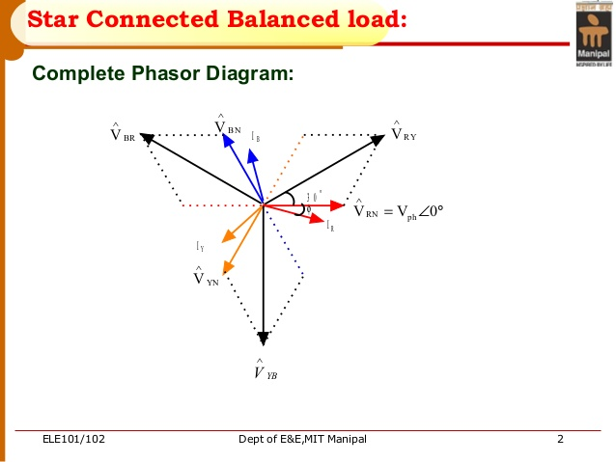

* Conclusion from the phasor diagram:

1. Phase currents lags behind the corresponding phase voltages by ø radians respectively as the load is inductive.
2. The line voltages are displaced by 1200 from each other.
3. The line voltages leads their respective phase voltages by 300.

* **Balanced Delta Load:**

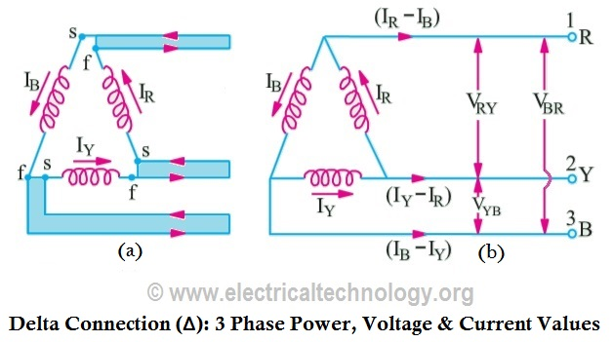

* **Relation between line and phase voltages:**

line voltage = phase voltage

* **Relation between line and phase current:**

line current is higher than phase current

IL = √3 Iph

* **Equations for three phase power:**
* In single phase ac circuit, the power consumed in each phase is given by,

Pph = Vph Iph cos ø ….(1)

where ø = angle between Vph and Iph

* For balanced three phase system, the total power consumed will be given by,

PT = 3 Pph = 3 Vph Iph cos ø …..(2)

* substituting Vph = VL/√3 and Iph = IL, we get,

Total power PT = 3 x VL/√3 x IL cos ø

∴ PT = √3 VL IL cos ø

* **Power factor:**

The load power factor for a 3 phase balanced delta load is equal to the power factor of each phase in the load.

∴ overall P.F. = cos ø

where ø = angle between the phase voltage and phase current

* **The complete phasor diagram:**

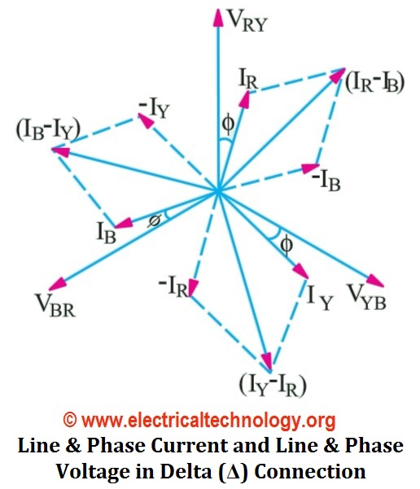

* Conclusion from the phasor diagram:

1. Phase currents lags behind the corresponding phase voltages by ø radians respectively as the load is inductive.
2. Every line current lags the respective phase current by 300.

* **Types of Power:**

1. **Active power P (watts):**

Total Active Power P = 3 x Vph x Iph x cos ø

= 3 VL/√3 x IL cos ø

= 3 VL x IL /√3 cos ø

∴ P = √3 VL IL cos ø watt ….(star or delta load)

1. **Reactive power Q (volt ampere VAR):**

Total Reactive Power Q = 3 Vph x Iph sin ø

∴ Q = 3 VL x IL sin ø VAR or kVAR ….(star or delta load)

1. **Apparent power S (volt ampere VA):**

Total apparent power S = 3 x apperent power per phase

∴ S= 3 x Vph x Iph = 3 xVL/√3 xIL ….(star or delta load)

∴ S = √3 VL IL (VA or kVA) ….(star or delta load)

* **Power Triangle:**

The power triangle for a 3-phase system.

(Apparent Power) = [(Active power)2 + (Reactive Power)2]

S = √P2 +Q2

* **Power Factor:**

The overall power factor of a three phase system is defined as the cosine of the angle between the phase voltage and phase current.



**Compare star & delta connection**

|  |  |  |  |
| --- | --- | --- | --- |
| **Sr.No.** | **Parameter** | **Star connection** | **Delta connection** |
| **1.** | **Connection** | **See fig.(a)** | **See fig.(b)** |
| **2.** | **Neutral point** | **Present** | **Absent** |
| **3.** | **Relation between phase and line voltages** | **VL = √3 Vph** | **VL =Vph** |
| **4.** | **Relation between phase and line currents** | **IL = Iph** | **IL = √3 Iph** |
| **5.** | **Total active power** | **P = √3 VL IL cos ø** | **P = √3 VL IL cos ø** |
| **6.** | **Total reactive power** | **Q = √3 VL IL sin ø** | **Q = √3 VL IL sin ø** |

**Q.Write the Applications of 3 Phase AC Circuits**

1. 3 phase induction motors.
2. 3 phase synchronous motors.
3. Submersible water pumps.
4. Various machines-tool applications (lathe machine, grinder, milling machine etc.)
5. Large factories and educational institutions.

**Unit 4 - Transformers & D.C. Motors**

**Marks – 14**

**CO: Connect transformers and DC motors for specific requirements.**

* **Transformer:**

The transformer is a static device (i.e. the one which does not contain any rotating or moving parts) which is used to transfer electrical energy from one ac circuit to another ac circuit, with increase or decrease in voltage/current but without any change in frequency.

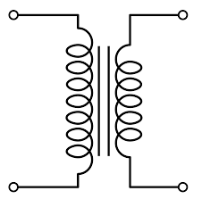 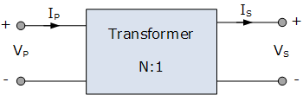

* **Function of transformer:**
* The electrical energy is generated and transmitted at extremely high voltages. The voltage is to be then reduced to a lower value for its domestic and industrial use.
* This is done by using a transformer. Thus it is possible to reduced the voltage level using a transformer called step down transformer.
* On the other hand, the transformer used to increase the voltage level is called step up transformer.
* When the transformer changes the voltage level, it changes the current level also.
* **Principle of Operation:**
* The construction of single phase transformer is as shown in fig. It consists of two highly inductive coils (windings) wound on an iron or steel core.
* The winding connected to ac supply is called as primary winding whereas the other one is called as the secondary winding.
* Operating principle of a transformer:

1. As soon as the primary winding is connected to the single phase ac supply, an ac current starts flowing through it.
2. The ac primary current produces an alternating flux ø in the core.
3. Most of this changing flux gets linked with the secondary winding through the core.
4. The varying flux will induce voltage into the secondary winding according to the Faraday’s law of electromagnetic induction.

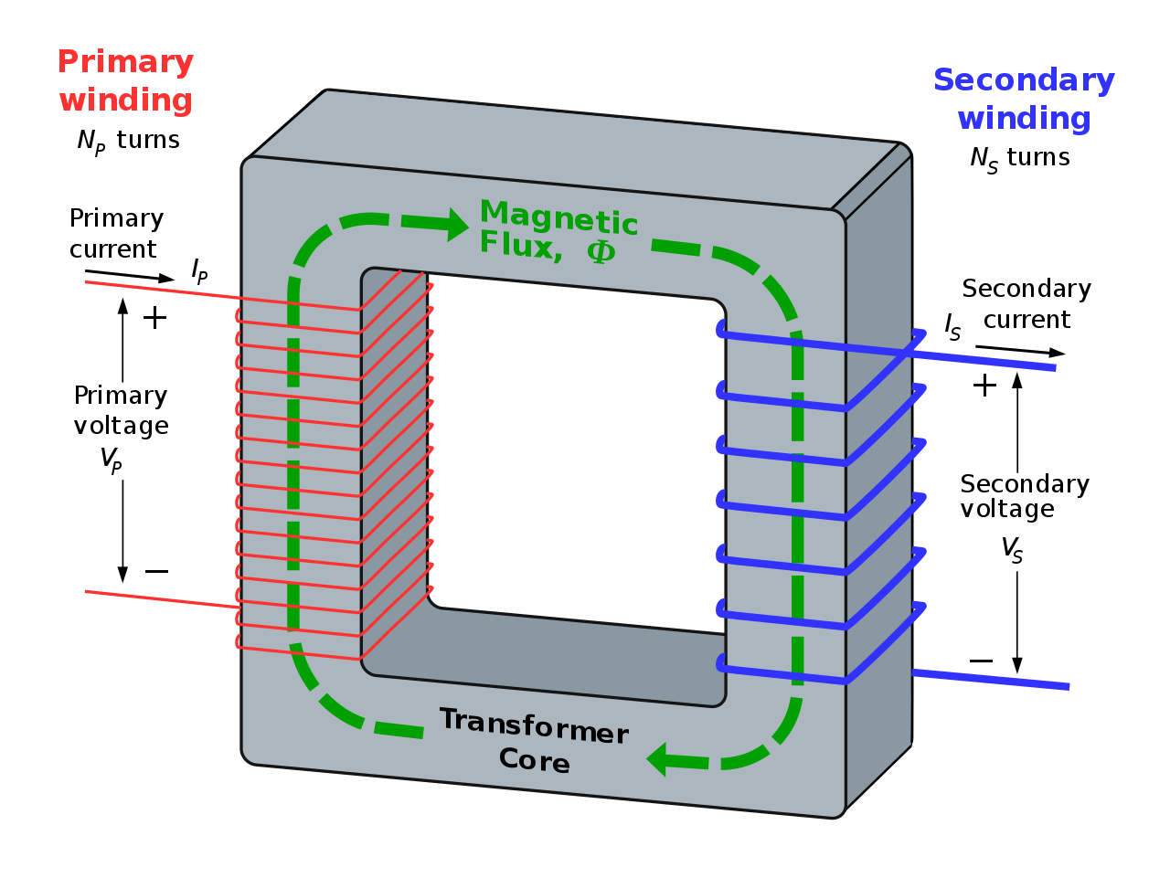

* Thus due to primary current, there is an induced voltage in the secondary winding due to mutual induction.
* Hence the induced emf in secondary is called as the mutually induced emf.

**Can the transformer operate on DC?**

* Answer is NO. Because with a DC primary current, the flux produced in the core will not alternate, it is of constant value.
* As there is no change in flux linkage, the induced emf in secondary winding is zero.
* **EMF equation of a transformer:**
* Let,  
  N1 = Number of turns in primary winding  
  N2 = Number of turns in secondary winding  
  Φm = Maximum flux in the core (in Wb) = (Bm x A)  
  f = frequency of the AC supply (in Hz)
* As, shown in the fig., the flux rises sinusoidally to its maximum value Φm from 0. It reaches to the maximum value in one quarter of the cycle i.e in T/4 sec (where, T is time period of the sin wave of the supply = 1/f).

Therefore, average rate of change of flux = Φm /(T/4)    = Φm /(1/4f)  
Therefore, average rate of change of flux = 4f Φm       ....... (Wb/s).

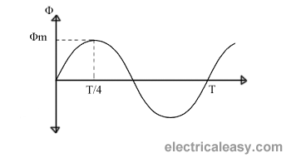

* Now, Induced emf per turn = rate of change of flux per turn  
  Therefore, average emf per turn = 4f Φm   ..........(Volts).
* Now, we know,  Form factor = RMS value / average value  
  Therefore,

RMS value of emf per turn = Form factor X average emf per turn.

* As, the flux Φ varies sinusoidally, form factor of a sine wave is 1.11  
  Therefore, RMS value of emf per turn =  1.11 x 4f Φm = 4.44f Φm.
* RMS value of induced emf in whole primary winding (E1) = RMS value of emf per turn X Number of turns in primary winding  
            E1 = 4.44f N1 Φm          ............................. eq (1)
* Similarly, RMS induced emf in secondary winding (E2) can be given as  
            E2 = 4.44f N2 Φm.          ............................ (eq 2)
* From the above equations 1 and 2,

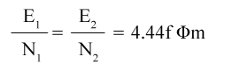

* **Factors affecting the induced emf are:**

1. Flux Φm
2. Frequency of applied voltage
3. Number of turns N.

* **Voltage ratio:**

The ratio of the primary and secondary terminal voltages (i.e. V1 & V2 ) is called as the voltage ratio.

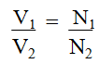

* **Transformation ratio (k):**

The transformation ratio for voltage is defined as the ratio of secondary voltage to the primary voltage of a transformer.

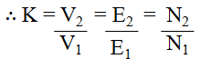

* **Turns ratio:**

The turns ratio of a transformer is defined as the ratio of the number of primary turns to the number of secondary turns.



* **Current ratios:**
* The transformer transfer electrical power from one side to the other (primary to secondary) with a very high efficiency (η).
* If we assume that the power loss taking place in the transformer is very low (η = 100%) then, we can write that

power input = power output

∴ V1 I1 cos ø1 = V2 I2 cos ø2 …….(7)

where I1 and I2 are the RMS values of the primary and secondary currents of the transformer respectively.

* cos ø1 and cos ø2 are the power factors of the primary and secondary sides of the transformer. Practically they are of same value.

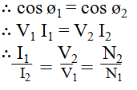

* **Types of transformers based on the value of K:**

1. Step up transformer:

If K > 1 or V2 > V1 is called step up transformer.

1. Step down transformer:

If K < 1 or V2 < V1 is called step down transformer.

1. One-to-one transformer:

If K=1 or V1 = V2 is called as a one-to-one transformer. It is also known as the isolation transformer.

* **Rating of Transformer:**
* Generally the rating of a machine should indicate the power supplied by it. But in case of transformer, the output power is not constant.
* Hence rating of a transformer is expressed in terms of voltage and current as follows:

**Rating of transformer = Primary voltage x primary current**

**or = Secondary voltage x secondary current**

* **The complete rating of a transformer:**

The complete rating of a transformer includes the ratio of primary and secondary voltages, kVA rating and supply frequencies as follows:

3300 V/ 240 V , 5 kVA , 50 Hz

where, 3300 V is primary voltage V1

240 V is secondary voltage V2

5 kVA is kVA rating and 50 Hz is the supply frequency.

* **Losses in a Transformer:**

An ideal transformer is loss free. But in the practical transformer there are following losses taking place.

1. Copper losses (Pc)
2. Iron losses (Pi):

i. Hysteresis losses

ii. Eddy current losses

1. **Copper losses (Pc)**

The total power loss is taking place in the winding resistances of the transformer is known as the copper loss.

∴ Copper loss = Primary copper loss + Secondary copper loss

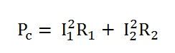

where, R1 and R2 are resistances of primary and secondary winding respectively.

1. **Iron loss (Pi):**

Iron loss Pi is the power loss taking place in the iron core of the transformer.

Pi = Hysteresis Loss + Eddy current loss

**i.Hysteresis losses:**

Hysteresis loss is directly proportional to frequency f . it is given by

PH = KH Bm1.67 fV …..[KH constant]

**ii. Eddy current losses:**

Due to time varying flux, there is some induced emf in the transformer core. This induced emf causes some currents to flow through the core body. These currents are known as the eddy currents.

Eddy current loss is proportional to square of frequency and square of thickness of laminations. It is given by,

PE = KE Bm2 f2.t2 ……[t = thickness]

* **Efficiency (η):**

The efficiency of a transformer is defined as the ratio of output power to input power. It is denoted by η.

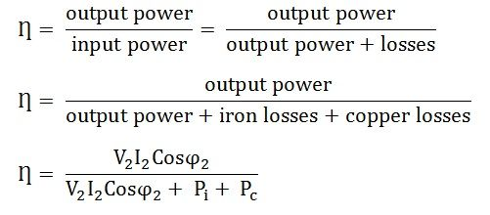

* **Voltage regulation:**

The voltage regulation of a transformer is defined as the change in secondary terminal voltage(V2) from no load to full load with the primary source voltage (V1) and the temperature of the transformer maintained constant.

* **Autotransformer:**
* The autotransformer is a special transformer in which a part of winding is common for the primary and secondary windings.
* It consists of only one winding wound on a laminated magnetic core, with rotary movable contact.
* The autotransformer can operate as a step down or a step up transformer.

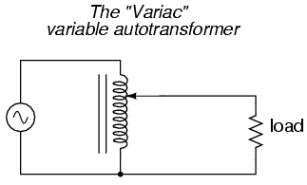

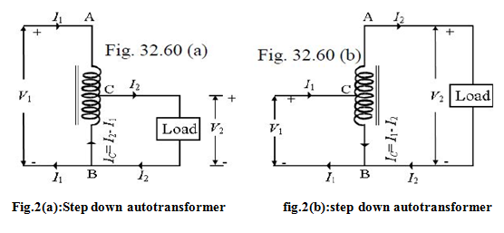

* **Applications of autotransformer:**

1. It can be used as a variac, i.e. variable ac supply to vary the ac voltage applied to the load smoothly from 0 V to about 270 V.
2. In order to start the ac machines such as induction motors or synchronous motors.
3. To vary the supply voltage (as per requirement) of a furnace.
4. As a dimmerstat: when the variac autotransformer is used to control the intensity of lamps in the cinema halls etc., it is called as the dimmerstat.

* **Comparison of two winding transformer and autotransformer:**

|  |  |  |  |
| --- | --- | --- | --- |
| **Sr.no.** | **Parameter** | **Autotransformer** | **Conventional transformer** |
| 1. | Definition | A transformer, having only one winding a part of which acts as a primary and the other as a secondary. | It is a static machine which transfers electrical energy from one end to another without changing frequency. |
| 2. | Number of Windings | Auto-transformer has only one winding wound on a laminated core | It has two separate winding, i.e., primary and secondary winding. |
| 3. | Insulation | The primary and secondary winding are not electrically insulated. | The primary and secondary winding are electrically insulated from each other. |
| 4. | Induction | Self Induction | Mutual Induction |
| 5. | Size | Small | Large |
| 6. | Power Transfer | Partly by transformation and partly by direct electrical connection. | Through transformation |
| 7. | Voltage Regulation | Better | Good |
| 8. | Winding Material | Less requires | More requires |
| 9. | Circuit | The primary and secondary winding circuits are connected magnetically. | The primary and secondary winding circuits are connected both electrically and magnetically. |
| 10. | Connection | Depends upon the tapping | Connect directly to the load. |
| 11. | Starting current | Decreases | Decreases by 1/3 times. |

DC Motor :

What is a motor.

It is a machine which converts electrical energy into mechanical energy.

AC motor:Motor that runs on AC electricity.

DC motor: Motor that runs on DC electricity.

* The Dc machines are of two types namely DC generators and DC motors.
* A DC generators converts mechanical energy into electrical energy whereas a DC motor converts the electrical energy into mechanical energy.

**Windings in DC Machine**

* In any dc machines, there are two windings:

1. Field winding 2. Armature winding

* Out of these, the field winding is stationary which does not move at all and armature winding is mounted on a shaft. So it can rotate freely.
* Connection of windings for operation as motor:
* To operate the dc machine as a motor, the field winding and armature winding is connected across a dc power supply.
* Explain the Principle of operation of DC motor:
* When current carrying conductor is placed in a magnetic field, it experienced a force.
* In case of DC motor, the magnetic field developed by the field current i.e. current flowing in field winding and armature winding plays the role of current carrying conductor
* So armature winding experienced a force and start rotating.

**Explain the Construction of DC Motor.**

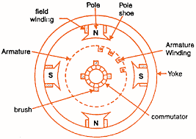

**Explain the Important parts of DC motor:**

1. Yoke 4. Armature
2. Field winding 5. Commutator, brushes & gear
3. poles 6. Brushes

**Yoke:**

* It acts as the outer support of a DC motor.
* It provides mechanical support for the poles.

**Poles:**

* pole of a dc motor is an electromagnet.
* The field winding is wound over the poles.
* Poles produces magnetic flux when the field winding is excited.

**3. Field winding:**

* The coils wound around the pole are called field coils and they are connected in series with each other to form field winding.
* When current passing through the field winding, magnetic flux produced in the air gap between pole and armature.

**Armature:**

* Armature is a cylindrical drum mounted on shaft in which number of slots are provided.
* Armature conductors are placed in these slots.
* Theses armature conductors are interconnected to form the armature winding.

**5. Commutator:**

* A commutator is a cylindrical drum mounted on the shaft alongwith the armature core.

It collects the current from the armature conductors and passed it to the external load via brushes.

**Brushes:**

* Commutator is rotating. So it is not possible to connect the load directly to it.
* Hence current is conducted from the armature to the external load by the carbon brushes which are held against the surface of commutator by springs.

**Types of DC Motors**

* Depending on the way of connecting the armature and field windings of a d.c. motors are classified as follows:

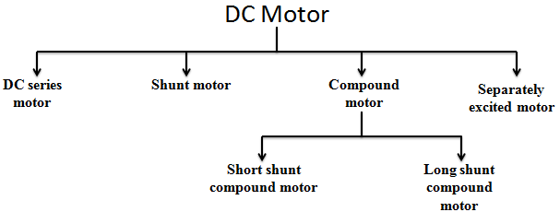

**DC Shunt Motor**

* In DC shunt type motor, field and armature winding are connected in parallel as shown in fig.(1), and this combination is connected across a common dc power supply.

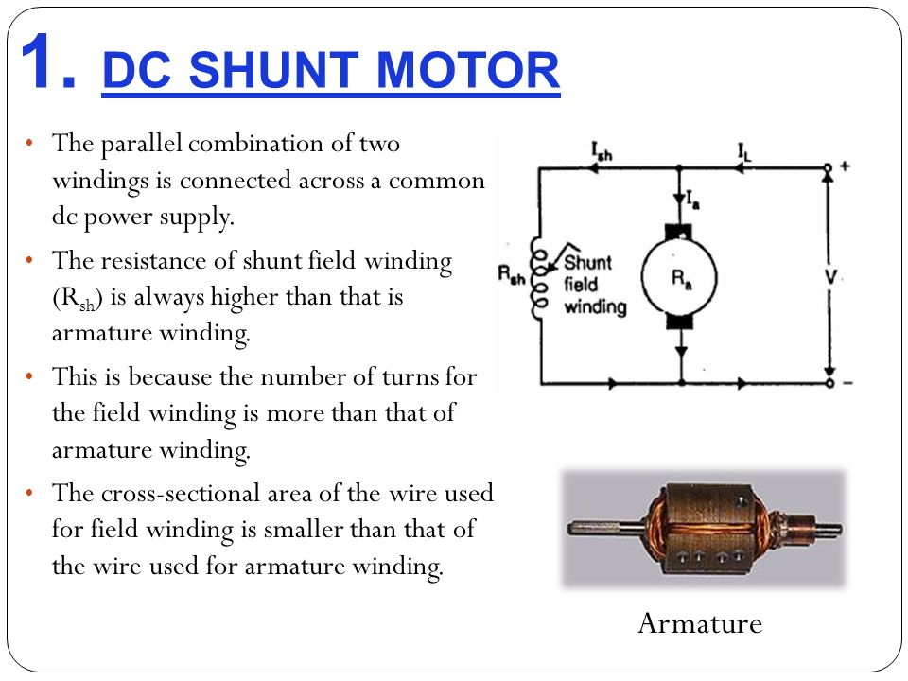

* **Shunt motor applications:**

1. Various machine tools such as lathe machines, drilling machines, milling machines etc.
2. Printing machines
3. Paper machines
4. Centrifugal and reciprocating pumps
5. Blowers and fans etc.

**DC Series Motor**

* In DC series motor, the armature and field windings are connected in series with each other as shown in fig.(1).

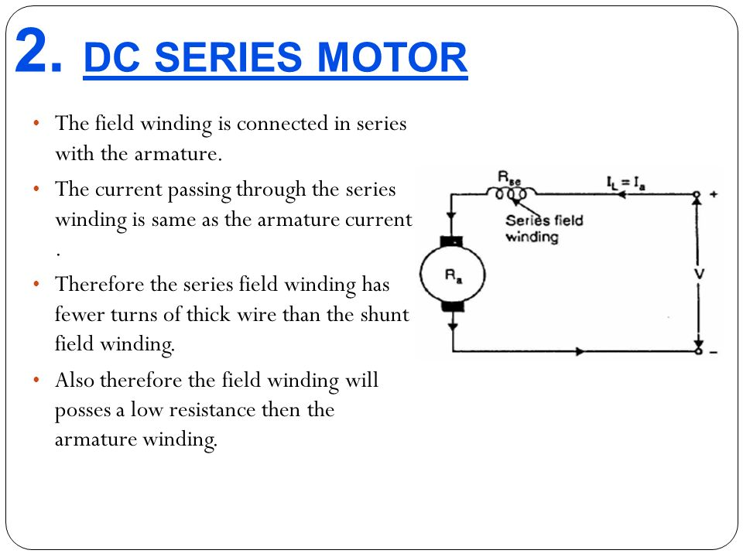

* **Series motor applications:**

1. Electric trains
2. Diesel-electric locomotives
3. Cranes
4. Hoists
5. Trolley cars and trolley buses
6. Rapid transit systems
7. Conveyers etc.

**DC Compound Motor**

1. **Long Shunt Compound Motor:**

* As shown in fig.(1), in long shunt dc motor, shunt field winding is connected across the series combination of the armature and series field winding.

**2. Short Shunt Compound Motor:**

* In short shunt compound motor, armature and shunt field windings are connected in parallel with each other and this combination is connected in series with the series field winding. This is shown in fig.(2).
* The long shunt and short shunt compound motors are further classified as **cumulative and differential compound motors**

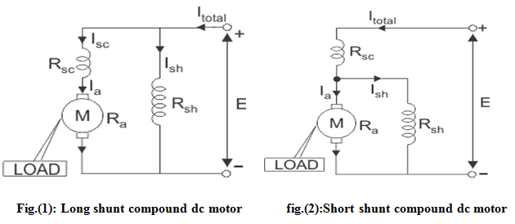

**Cumulative compound motor applications:**

1. Elevators
2. Rolling mills
3. Planers
4. Punches
5. Shears

**4. Differentials compound motors applications:**

* The speed of these motors will increase with increase in the load, which leads to an unstable operation.
* Therefore we cannot use this motor for any practical applications .